Exercise Javascript Forms

**Evaluated skills :**

*→ Forms*

**Question 1 :** Fill in the fields left blank

<textarea> Content of the textarea </ textarea>

How to retrieve the text that the user has entered in the field above?

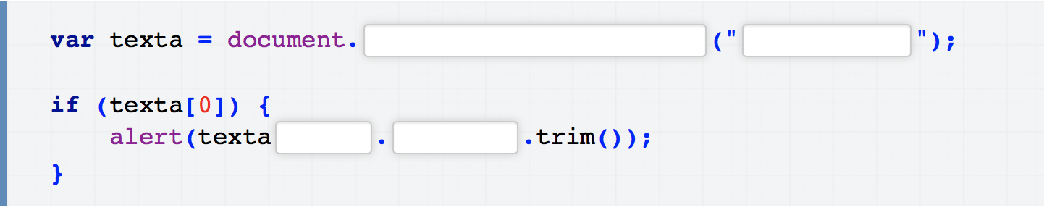

**Question 2 :** Fill in the fields left blank

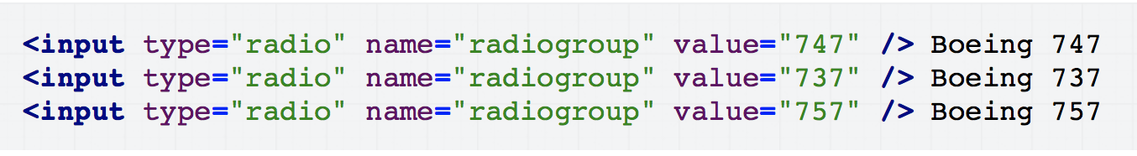

Considering this code, fill in the code below to be able to recover the selected radio button

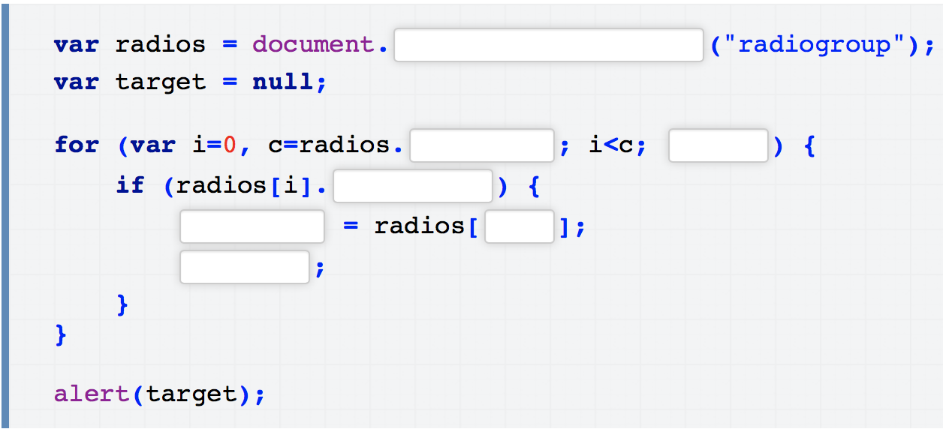

**Question 3 :** Fill in the fields left blank

Complete the following code. The goal is, that during the typing, the contents of the field is retranscribed in the element <output>

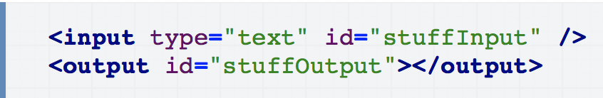

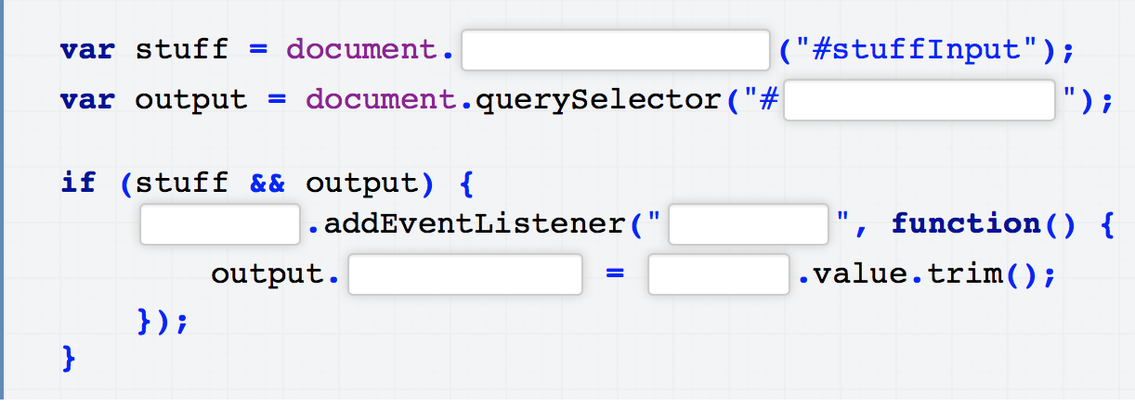

**Question 4 :** Fill in the fields left blank

Complete the following code to check if all <input type = "text" /> elements contain a value.

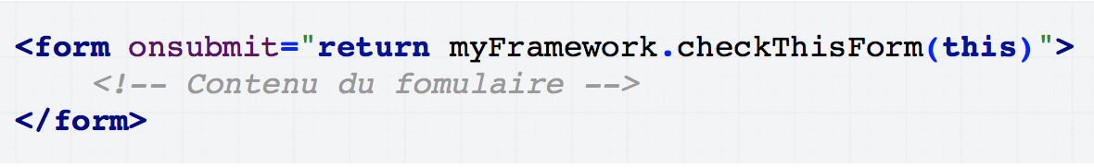

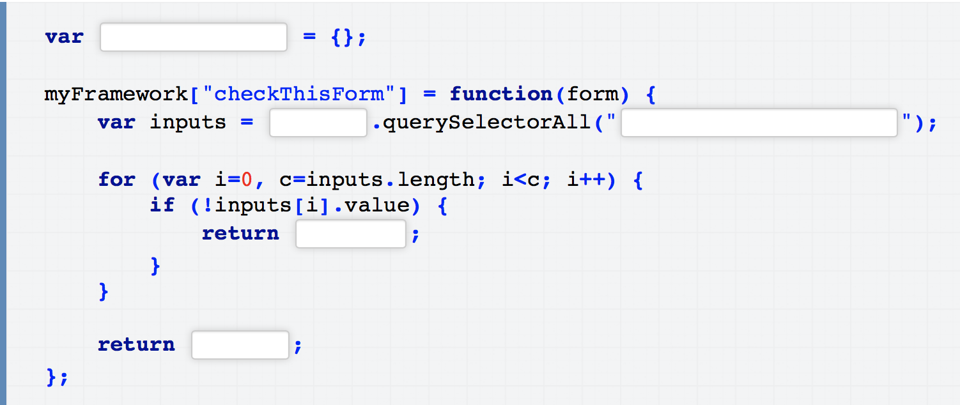

**Correction :**

**Question 1 :**

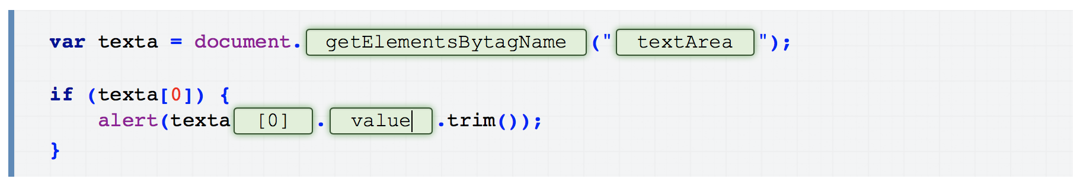

**Questions 2 :**

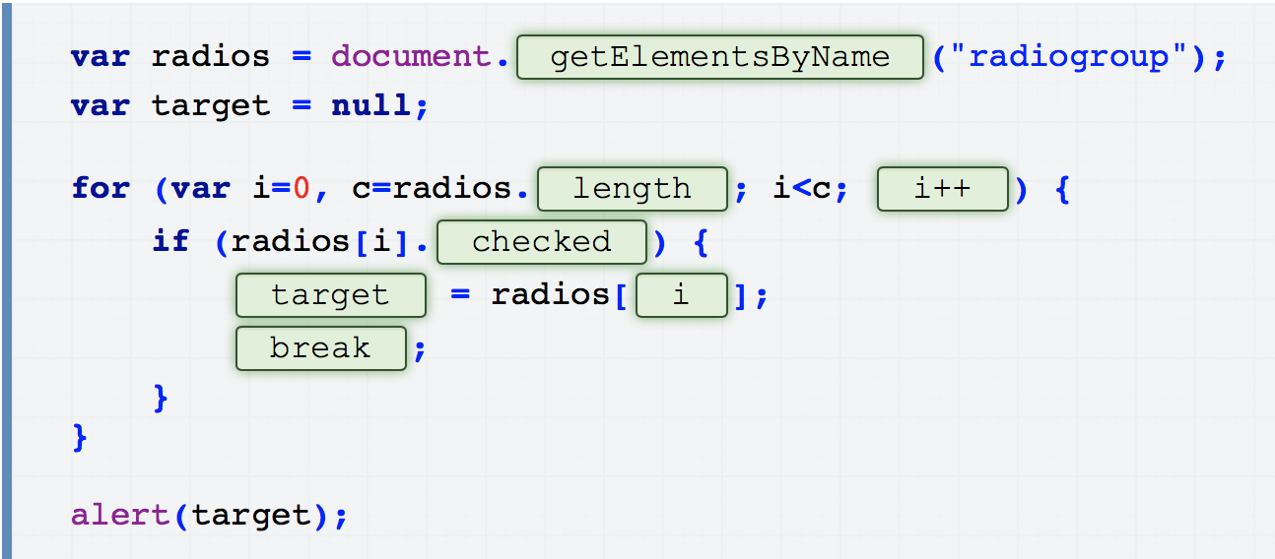

**Question 3 :**

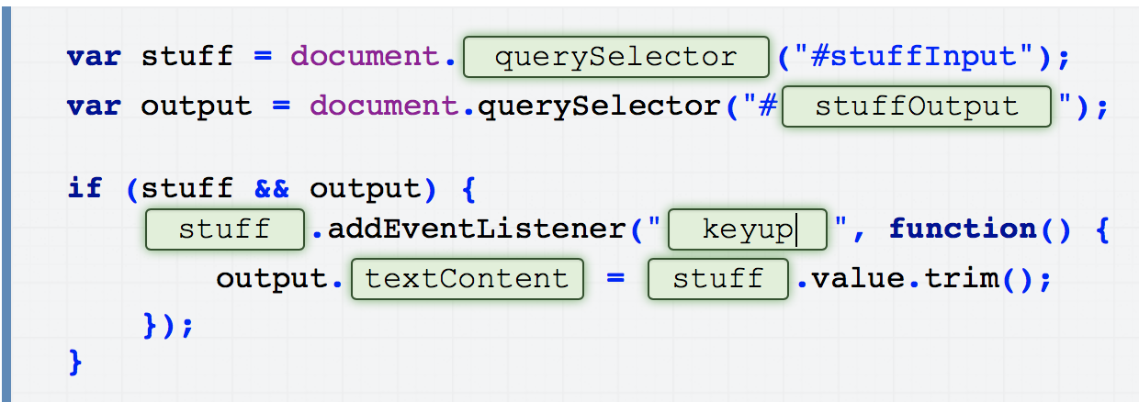

**Question 4 :**

